Hi Students
Our next unit of counseling instruction lessons is careers. For this reason, I wanted you to be able to explore your strengths and career options on your own using the program called Thrively. This program will ask you questions and help you discover your own personal strengths and expand your growth mindset. You can use this program at your own pace. I can’t wait to see what you discover
Steps for using Thrively
- With your parent’s permission and help, join Thrively using the link below
https://www.thrively.com/student
- Click join
- Complete the registration
You will need your name and an email address (have your parents’ set one up for you)
You will create a password (make sure that you write it down or have your parents save it)
Your parents are going to want to see what all you are learning. Fill out the parent email info tab
- Next copy this invite code so that your school counselors can help you on your exploration journey Invite Code: 18UXWCGI
- You are ready to explore
- To personalize your exploration, Thrively will ask you to click on your interests –
Choose as many as you want
- To really understand your interests, Thrively will ask you to choose specific interests in each category – For example: Category: Fine Arts > Interests: painting, drawing, graphic design, etc
- Next, choose your top 3 career choices from a list provided.
- Now you will see your personalized dashboard 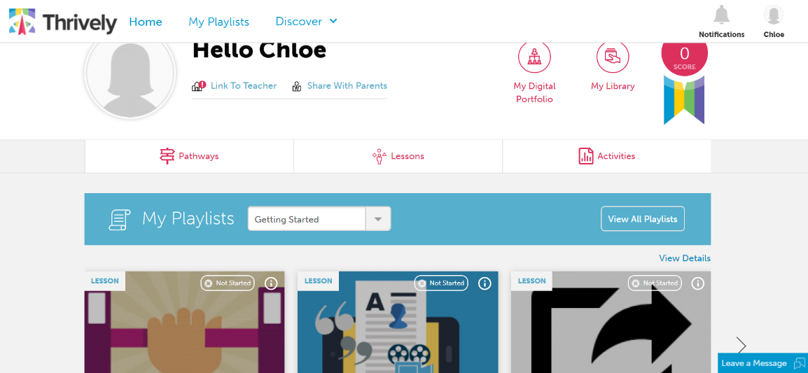
- At your own pace complete the lessons in the careers playlist to discover your personal “genius”

